Privacy Protection and Intrusion Avoidance for Cloudlet-based Medical Data Sharing
ABSTRACT:
With the popularity of wearable devices, along with the development of clouds and cloudlet technology, there has been increasing need to provide better medical care. The processing chain of medical data mainly includes data collection, data storage and data sharing, etc. Traditional healthcare system often requires the delivery of medical data to the cloud, which involves users’ sensitive information and causes communication energy consumption. Practically, medical data sharing is a critical and challenging issue. Thus in this paper, we build up a novel healthcare system by utilizing the flexibility of cloudlet. The functions of cloudlet include privacy protection, data sharing and intrusion detection. In the stage of data collection, we first utilize Number Theory Research Unit (NTRU) method to encrypt user’s body data collected by wearable devices. Those data will be transmitted to nearby cloudlet in an energy efficient fashion. Secondly, we present a new trust model to help users to select trustable partners who want to share stored data in the cloudlet. The trust model also helps similar patients to communicate with each other about their diseases. Thirdly, we divide users’ medical data stored in remote cloud of hospital into three parts, and give them proper protection. Finally, in order to protect the healthcare system from malicious attacks, we develop a novel collaborative intrusion detection system (IDS) method based on cloudlet mesh, which can effectively prevent the remote healthcare big data cloud from attacks. Our experiments demonstrate the effectiveness of the proposed scheme.

EXISTING SYSTEM:
- Lu et al. proposed a system called SPOC, which stands for the secure and privacy-preserving opportunistic computing framework, was proposed to treat the storage problem of healthcare data in a cloud environment and addressed the problem of security and privacy protection under such an environment.
- Cao et al., an MRSE (multikeyword ranked search over encrypted data in cloud computing) privacy protection system was presented, which aims to provide users with a multi-keyword method for the cloud’s encrypted data. Although this method can provide result ranking, in which people are interested, the amount of calculation could be cumbersome.
- In Zhang et al., a priority based health data aggregation (PHDA) scheme was presented to protect and aggregate different types of healthcare date in cloud assisted wireless boby area network (WBANs).

DISADVANTAGES OF EXISTING SYSTEM:
- Causes communication energy consumption.
- Practically, medical data sharing is a critical and challenging issue
- No Trust.
PROPOSED SYSTEM:
- This paper proposes a cloudlet based healthcare system. The body data collected by wearable devices are transmitted to the nearby cloudlet. Those data are further delivered to the remote cloud where doctors can access for disease diagnosis.
- According to data delivery chain, we separate the privacy protection into three stages. In the first stage, user’s vital signs collected by wearable devices are delivered to a closet gateway of cloudlet. During this stage, data privacy is the main concern. In the second stage, user’s data will be further delivered toward remote cloud through cloudlets.
- A cloudlet is formed by a certain number of mobile devices whose owners may require and/or share some specific data contents. Thus, both privacy protection and data sharing are considered in this stage. Especially, we use trust model to evaluate trust level between users to determine sharing data or not.
- Considering the users’ medical data are stored in remote cloud, we classify these medical data into different kinds and take the corresponding security policy.
- In addition to above three stages based data privacy protection, we also consider collaborative IDS based on cloudlet mesh to protect the cloud ecosystem.
ADVANTAGES OF PROPOSED SYSTEM:
- A cloudlet based healthcare system is presented, where the privacy of users’ physiological data and the efficiency of data transmissions are our main concern. We use NTRU for data protection during data transmissions to the cloudlet.
- In order to share data in the cloudlet, we use users’ similarity and reputation to build up trust model. Based on the measured users’ trust level, the system determines whether data sharing is performed.
- We divide data in remote cloud into different kinds and utilize encryption mechanism to protect them respectively.
- We propose collaborative IDS based on cloudlet mesh to protect the whole healthcare system against malicious attacks.
SYSTEM ARCHITECTURE:
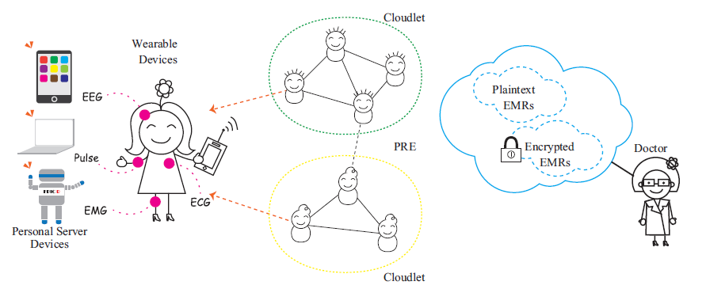
MODULES:
- Patient
- Doctor
- CloudLet
- Intruder
MODULES DESCRIPTION:
Patient
In this module, there are n numbers of patient are present. Patient should register before doing some operations. And register user details are stored in user module. After registration successful he has to login by using authorized user name and password. Login successful he will do some operations like Send Appoinment Request ,Access Request,Receive Prescription .
Doctor:
In this doctor module, we develop the following functionalities:
Login
View Patient Request
Send Access Request to Cloudlet 1 or 2 or 3
View patient records
Update patient health records like ecg,Send prescription details to user

CloudLet:
In this module, the CloudLet has to login by using valid name and password. After login successful he can do some operations such as Add Docter, View all Docter Information, view Patient, and view the Intruder Detection Details.

Intruder:
In this Intruder module, we develop the following functionalities:
Login
View patient records means it is showing only encrypted format
Try to modify data means alert mail send to patient or cloud let.
SYSTEM REQUIREMENTS:
HARDWARE REQUIREMENTS:

- System : Pentium Dual Core.
- Hard Disk : 120 GB.
- Monitor : 15’’ LED
- Input Devices : Keyboard, Mouse
- Ram : 1 GB

SOFTWARE REQUIREMENTS:

- Operating system : Windows 7.
- Coding Language : JAVA/J2EE
- Tool : Netbeans 7.2.1
- Database : MYSQL

REFERENCE:
Min Chen, Senior Member, IEEE, Yongfeng Qian, Jing Chen, Kai Hwang, Fellow, IEEE, Shiwen Mao, Senior Member, Long Hu, “Privacy Protection and Intrusion Avoidance for Cloudlet-based Medical Data Sharing”, IEEE Transactions on Cloud Computing, 2017.

